Radiated Immunity Test Report

Contents

1. Test lab facility 2

Test Site: 2

Facility name: 2

Facility address: 2

Facility site description: 2

Test Standards 2

EMC Directive 2014/30/EU 2

Test Equipment: 2

Environmental conditions: 2

Test Operator and Date: 3

2. Product Information 3

3. EUT setup 3

Photograph of EUT: 4

4. Test Result 5

5. Summary 12

# Test lab facility

## Test Site:

Facility name: Keysight Technology, Technology Order Fulfillment, Colorado Springs Hardware Test Center.

Facility address: 1900 Garden of the Gods Rd, Colorado Springs, CO. 80907

Facility site description:

The Keysight Technologies Technology Order Fulfillment Colorado Spring Hardware Test Center is a certified radiated interference testing facility, which is comply with the standard requirements defined by IEC 61326.

## Test Standards

### EMC Directive 2014/30/EU

IEC 61326-1:2012 / EN 61326-1:2013 (Basic)

Radiated Immunity Reference Standards:

IEC 61000-4-3:2016 Group 1 Class A.

The products were tested in a typical configuration with Keysight Technologies test systems. This product is intended for use in a basic electromagnetic environment.

## Test Equipment:

|  |  |
| --- | --- |
| Traceability |  |
| Power line Immunity Tester | Model:EMCPro, SN:102311, Calibration Exp.:8/22/2019 |
| Misc. Information |  |
| Test Standard | IEC 61000-4-5 / EN 61000-4-5 Basic ETM 765.002 |
| Test Standard | IEC 61000-4-6 / EN 61000-4-6 Basic ETM 765.002 |
| Test Standard | IEC 61000-4-11 / EN 61000-4-11 Basic ETM 765.002 |
| Test Site | Colorado Springs TOF Hardware Test Center |
| Test Voltage | 110V |
| Test Software Version | V1.5 |

## Environmental conditions:

Temperature: 72°F; Humidity :50 RH

Note: There will be no effect to the result due to changes in mains voltage or frequency.

## Test Operator and Date:

Operator: Clifford; Report generated at: Jun.21,2019 11:30:48 AM

# Product Information

|  |  |
| --- | --- |
| Product Name: | Myst LP2 |
| Product Model: | MXR608A |
| Product SN: | LP2-19 SN 59140019 |
| Project Stage: | LP2 |
| Deliver date of the test samples: | 5/31/2019 |
| DUT power: | 110V |
| Auxiliary equipment list: | N/A |
| Model numbers covered by the test: | MXR604A MXR 608A |
| .-Hardware Difference | N/A |
| .-Software/firmware difference: | N/a |
| .-Cosmetic difference: | NA |
| Test Configuration |  |
| Test Software Version | V1.5 |

# EUT setup

Radiated Immunity Test Setup- Table-Top and Control Room

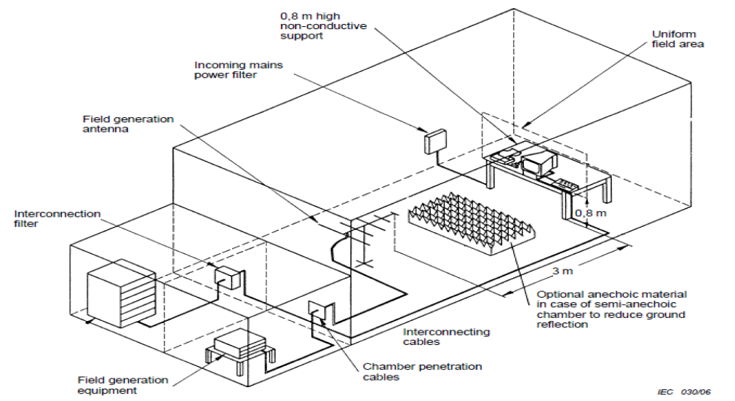

## Photograph of EUT:

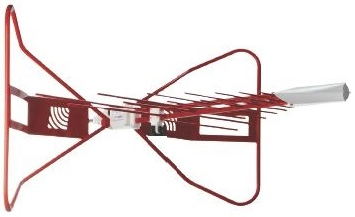

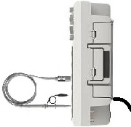

# Test Result

**Test Parameters:**

Frequency 80 MHz - 6 GHz; 80% Amplitude Modulated at 1 KHz

Sweep Rate 2.5 Seconds dwell per 1% step, 1.73E-03 Decades per Second

Filed Strength 3 v/m

Polarity Horizontal and Vertical

Rotation Front (0°) Left (90° ) Rear (180°) and Right (270°)

================================================================================   
KeyTek CEWare Compliance Tester Log Report 15 February 2019   
================================================================================   
REMOTE/TESTER RUN   
Versions: SW v3.00 FW v6.06 Str v6.00 EMCPro S/N   
Operator: Clifford Hu   
Sequence File: DVD-61000-4-5-11_newstandard 2KV.SEQ   
EUT: Coyote New Line Filter   
================================================================================   
   
--------------------------------------------------------------------------------   
DSOX4104A MY57190468   
--------------------------------------------------------------------------------   
   
11:36:42A SEQUENCE START   
   
SEQUENCE TYPE SEQUENCE DESCRIPTION   
EFT User Defined 1000-4-4 (EFT To Power Lines)   
   
 Frequency Voltage Output:LC Duration   
11:36:42A 5.0 kHz -2000V MAINS:L1 60 sec.   
11:37:52A 5.0 kHz 2000V MAINS:L1 60 sec.   
11:39:02A 5.0 kHz -2000V MAINS:L2 60 sec.   
11:40:12A 5.0 kHz 2000V MAINS:L2 60 sec.   
11:41:22A 5.0 kHz -2000V MAINS:PE 60 sec.   
11:42:32A 5.0 kHz 2000V MAINS:PE 60 sec.   
   
SEQUENCE TYPE SEQUENCE DESCRIPTION   
EFT Standard Class1   
   
 Frequency Voltage Output:LC Duration   
11:43:41A 5.0 kHz -500V CLAMP 60 sec.   
11:44:49A 5.0 kHz 500V CLAMP 60 sec.   
   
SEQUENCE TYPE SEQUENCE DESCRIPTION   
Srg 1.2/50 User Defined EN 61000-4-5 (Surge 1.2/50 us)   
   
 Waveform Voltage Output:LC Phs Ref Phs Ang Tests Delay   
11:45:53A 12 Ohm -2000V MAINS:L1/PE L1 0 deg. 5 60 sec.   
11:51:15A 12 Ohm -2000V MAINS:L1/PE L1 90 deg. 5 60 sec.   
11:56:37A 12 Ohm -2000V MAINS:L1/PE L1 270 deg. 5 60 sec.   
12:01:59P 12 Ohm 2000V MAINS:L1/PE L1 0 deg. 5 60 sec.   
12:07:22P 12 Ohm 2000V MAINS:L1/PE L1 90 deg. 5 60 sec.   
12:12:44P 12 Ohm 2000V MAINS:L1/PE L1 270 deg. 5 60 sec.   
12:18:07P 12 Ohm -2000V MAINS:L2/PE L1 0 deg. 5 60 sec.   
12:23:29P 12 Ohm -2000V MAINS:L2/PE L1 90 deg. 5 60 sec.   
12:28:52P 12 Ohm -2000V MAINS:L2/PE L1 270 deg. 5 60 sec.   
12:34:14P 12 Ohm 2000V MAINS:L2/PE L1 0 deg. 5 60 sec.   
12:39:37P 12 Ohm 2000V MAINS:L2/PE L1 90 deg. 5 60 sec.   
12:44:59P 12 Ohm 2000V MAINS:L2/PE L1 270 deg. 5 60 sec.   
12:50:22P 2 Ohm -1000V MAINS:L1/L2 L1 0 deg. 5 60 sec.   
12:55:44P 2 Ohm -1000V MAINS:L1/L2 L1 90 deg. 5 60 sec.   
01:01:07P 2 Ohm -1000V MAINS:L1/L2 L1 270 deg. 5 60 sec.   
01:06:29P 2 Ohm 1000V MAINS:L1/L2 L1 0 deg. 5 60 sec.   
01:11:51P 2 Ohm 1000V MAINS:L1/L2 L1 90 deg. 5 60 sec.   
01:17:14P 2 Ohm 1000V MAINS:L1/L2 L1 270 deg. 5 60 sec.   
   
01:22:37P SEQUENCE COMPLETE   
   
 [1]   
================================================================================   
KeyTek CEWare Compliance Tester Log Report 20 February 2019   
================================================================================   
REMOTE/TESTER RUN   
Versions: SW v3.00 FW v6.06 Str v6.00 EMCPro S/N NA   
Operator: Clifford Hu   
Sequence File: QFP-61000-11_newstandard.SEQ   
EUT:   
================================================================================   
   
09:26:11A SEQUENCE START   
   
SEQUENCE TYPE SEQUENCE DESCRIPTION   
PQF User Defined PQF61000-4-11   
   
 Test Level Phs Ang Dur. Value Duration Tests Delay   
09:26:11A 0% Open 0 deg. 0.50 cyc 3 10 sec.   
09:26:47A 0% Open 180 deg. 0.50 cyc 3 10 sec.   
09:27:22A 0% Open 0 deg. 1.00 cyc 3 10 sec.   
09:27:57A 0% Open 180 deg. 1.00 cyc 3 10 sec.   
09:28:33A 70% Dip 0 deg. 25.00 cyc 3 10 sec.   
09:29:09A 70% Dip 180 deg. 25.00 cyc 3 10 sec.   
09:29:45A 0% Short 0 deg. 250.00 cyc 3 10 sec.   
09:30:33A 0% Short 180 deg. 250.00 cyc 3 10 sec.   
   
09:31:20A SEQUENCE COMPLETE   
--------------------------------------------------------------------------------   
Passed   
--------------------------------------------------------------------------------   
   
   
   
   
   
   
   
   
   
   
   
   
   
   
   
   
   
   
   
   
   
   
   
   
   
   
   
   
   
 [1]

|  |  |  |  |  |
| --- | --- | --- | --- | --- |
| **Criteria:** | | A. Pass - Normal performance within specified limits. | | |
|  | | B. Pass - Temporary degradation, self recoverable. | | |
|  | | C. Pass - Temporary degradation, requires operator intervention. | | |
|  | | D. Fail - Not recoverable, component damage. | | |
|  | |  | | |
|  |  | |  |  |

|  |  |  |  |
| --- | --- | --- | --- |
| Field Uniformity Calibration Data | | | |
|  |  | | |
| Field Uniformity Exceptions: (>6dB) | | | |
|  |  |  |  |
|  | Horizontal Axis | 2107.0 MHz | 8.80 dB |
|  | Horizontal Axis | 5040.0 MHz | 7.13 dB |
|  | Horizontal Axis | 5499.0 MHz | 6.37 dB |
|  | Vertical Axis | None | N/A |
|  |  |  |  |
|  |  |  |  |
|  |  |  |  |
|  |  |  |  |
|  |  |  |  |
|  |  |  |  |
|  |  |  |  |
|  |  |  |  |
|  |  |  |  |

# Summary

The unit passed the Radiated Immunity Test!